**STEP:-1 GO TO YOUR BIOS SETUP**

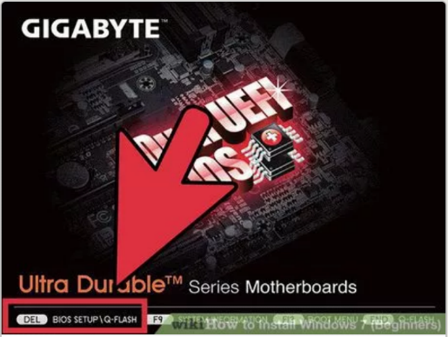

**STEP:-2 GO TO YOUR BOOT MENU**

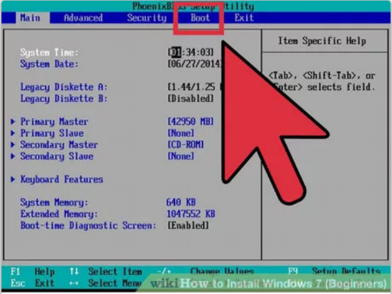

**STEP:-3 CHANGE THE PRORITRY OF BOOTABLE DISK DRIVE**

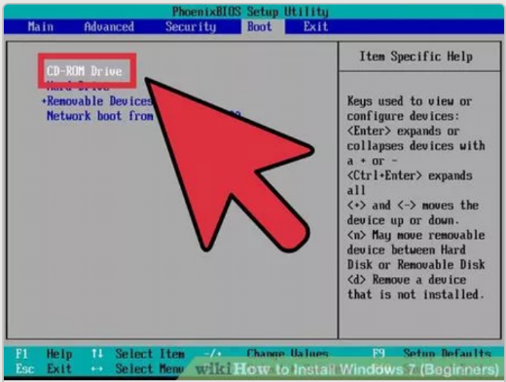

**SETP:- 4 GO TO EXIT TAB AND SELECT EXIT SAVING CHANGES**

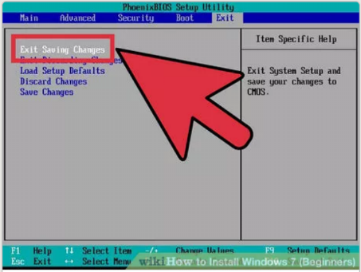

**STEP:-5 CLICK YES**

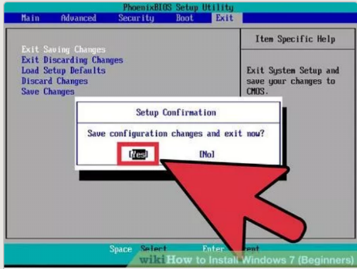

**STEP:- 6 RESTART THE SYSTEM**

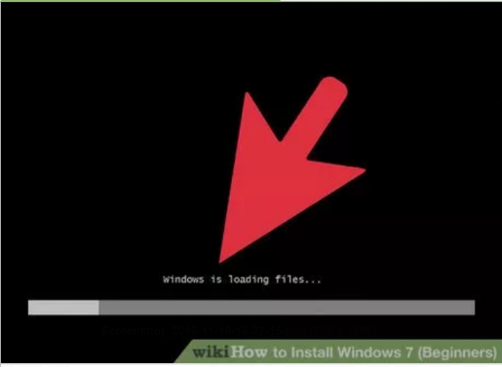

**STEP:- 7 SELECT NEXT**

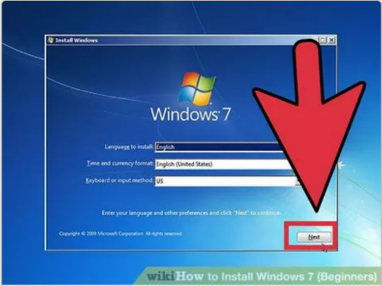

**STEP:- 8 SELECT INSTALL NOW**

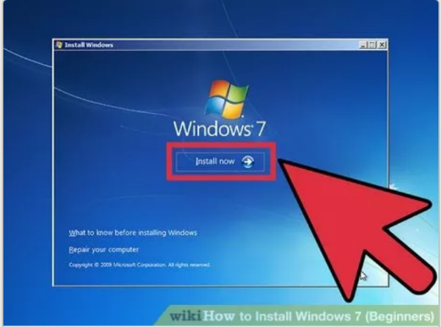

**STEP:- 9 CHECK THE I ACCEPT AGRREMENT AND CLICK NEXT**

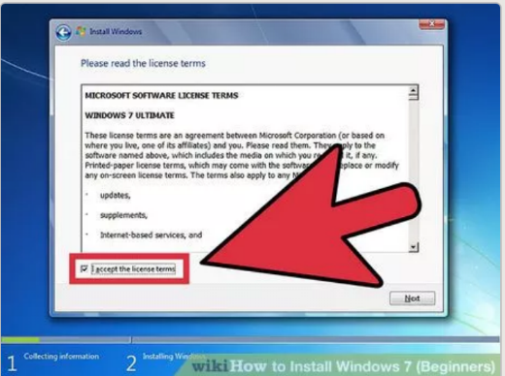

**STEP:-10 SELECT CUSTOM INSTALLATION**

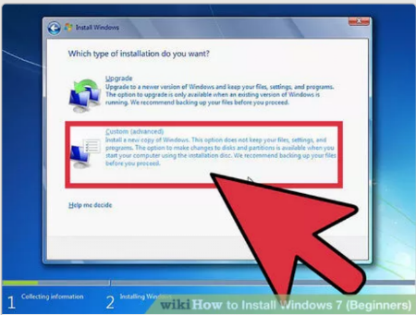

**STEP:-11 SELECT INSTALATION DISK PART**

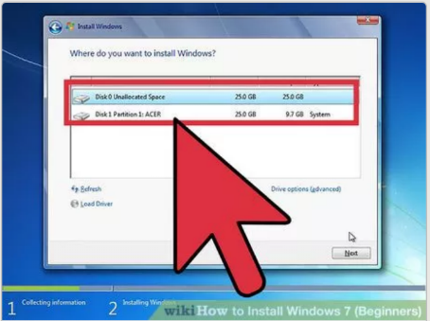

**STEP:- 12 WAIT FOR SOME TIME FOR INSTALLING OPERATING SYSTEM.**

